Tracy Dixon Mind & Body Health, Fitness & Well-Being
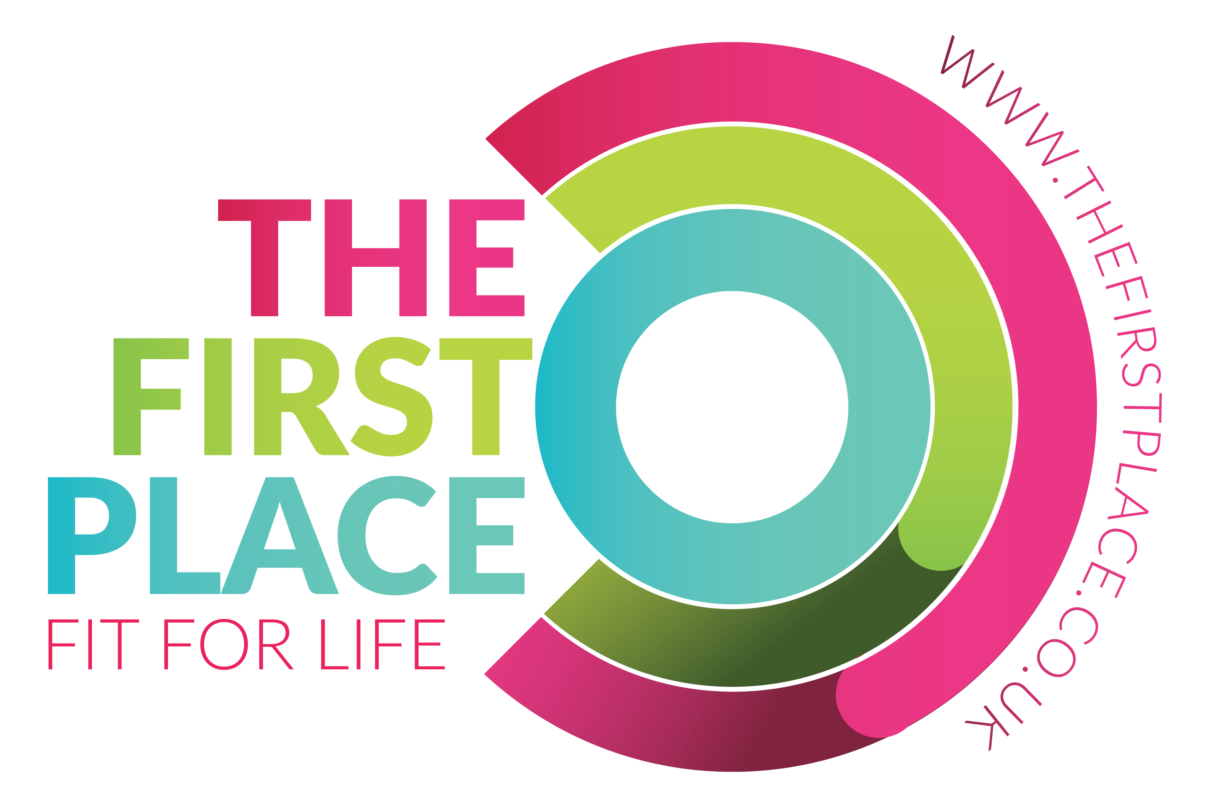
Body Pump & Tabata HIIT-New 16 week Programme
Sunday 5th January- 18th April 2020
SIGN UP- PRIORITY BOOKING FORM

What does a priority booking form guarantee you?
- When you sign up to Body Pump & HIIT using the priority booking from it guarantees your place
throughout the duration of the 16 week programme.
- All classes are held at The First Place, Kendal, LA9 5AF- A brand NEW Venue for Fitness
- Classes cancelled within 24 hours of commencement incur the full class fee.
How to pay?
Master Classes:
£15 payment in advance will secure your place.
Classes:
Are pre-booked & £7.50 pay as you go
You can by pay using bank transfer or cash on the day.
Sort: 010466
Account: 33745269

THE MASTER CLASSES- Limited places- learn & do all the new exercises correctly
WHY DO A MASTER CLASS?
- Run through the new programme track by track in detail before you enter a class.
- Do all the exercises, get feedback on technique, understand how to modify & progress.
- Good technique, knowing which muscles are working during the exercises ensures; safety,
effectiveness & the BEST RESULTS you can get from the 16 weeks.
The date | Time | $√$ To book
Saturday 11th January | 3.00-4.30pm
Saturday 11th January | 4.30-6.00pm
Sunday 12th January | 9.30-11.00am
Sunday 12th January | 11.00-12.30pm

BODY PUMP & TABATA HIIT – WEEKLY CLASSES FROM 5th January 2020
DATES/HOLS
CLASSES START FROM SUNDAY
5th January 2020

HOLIDAY TERM DATES There will be no classes from;
Sunday 5th –
Sunday 12th APRIL

Day | Time | $√$ To book
Saturday | 7.45-9.00am
Sunday | 8.00-9.15am
Monday | 12.00-1.15pm
Tuesday | 10.15-11.30am
Wednesday | 9.10-10.25am
Wednesday | 5.00-6.15pm
Wednesday | 6.15-7.30pm
Wednesday | 8.00-9.15pm
Thursday | 9.10-10.25am

YOUR DETAILS- Thank you
Full Name
Email address
Mobile Number
Date of Birth
Holiday dates between 5 Jan-12 April
Any relevant information regarding health, medication or special needs in relation to class
** Your personal details are important to me & will be stored securely. I will only use your personal details:
- To send you the personal Sunday Morning Motivational Message by email
- To inform you of any class changes by email
- To use your mobile number in an emergency

WHAT HAPPENS NEXT?
- Take a picture or copy of your priority booking form
- Fill out your form; hand it to me in class or email me a copy
- I will contact you at least 7 days prior to the Master Classes with all the details & information you need to know
- I will confirm your class selections by email at least 7 days prior to your classes commencing
www.tracydixonmindandbodyfit.com @tracymindbodyfit @tracydixonmindandbodyfit

